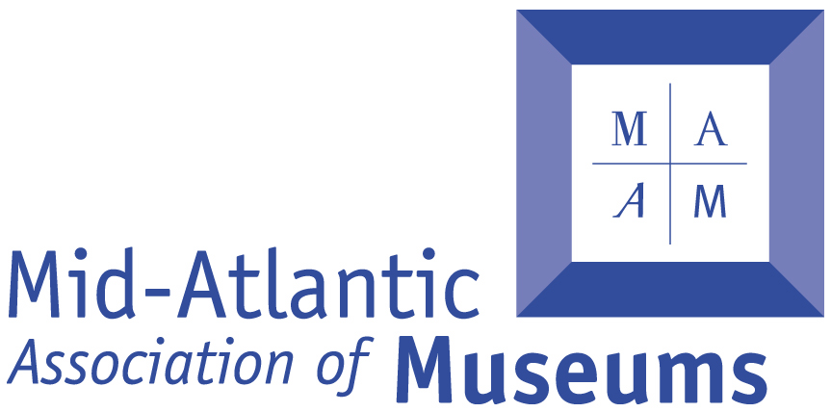

Mid-Atlantic Associations of Museums
2018 Building Museums® Symposium
CALL FOR BUILDY AWARD NOMINATIONS
March 9-11, 2018 at the DoubleTree Philadelphia Center City, Philadelphia, PA
Nomination Deadline: Friday, September 15, 2017 by 5:00PM

WHAT IS THE BUILDY AWARD?

This national award recognizes the most outstanding recent museum building projects. The purpose of the Buildy Award is to increase awareness within the field, and by the public at large, of the value of museums and the need for their ongoing rehabilitation and expansion to serve future generations.

Award winners will be announced at the Symposium in Philadelphia, PA during the 2018 Building Museums® Symposium, at the DoubleTree Philadelphia Center City hotel from March 9th through 11th, with several hundred peers in attendance. More than one award may be presented in order to recognize projects of varied type and scope. The Director/CEO of each winning museum, as a representative of the whole ownership side of the team, will present their projects and receive a plaque commemorating the museum’s achievement. Recipients of the Award will be featured in a press release distributed to museum-related, national and international publications, as well as other media.

Nominations are solicited from all Museum Directors with qualifying projects. Architects and other project team members are encouraged to collaborate with the Museum Directors to complete the nomination. Nominations submitted previously are eligible for resubmission if the project still meets the requirements and resubmissions are encouraged.

WHO GIVES THE BUILDY AWARD?

The award is given by The Mid-Atlantic Association of Museums (MAAM) at the Building Museums® Symposium. MAAM is a non-profit organization devoted to museums and institutions in the Mid-Atlantic region (DC, DE, MD, PA, NY, and NJ) as well as the professionals who serve them. The mission of the Association is to support and promote excellence, ethics, and accessibility in museum practices to make the museums of the Mid-Atlantic region better able to preserve and interpret our diverse cultural, scientific, and aesthetic heritage The selection of the award recipient is made by members of the Building Museums® organizing committee.

The Building Museums® Symposium is for museum leaders, architects, planners, project managers, technical experts, and all those who plan or implement new construction, renovation, or expansion projects for museums. Whether your institution is a small historic site under renovation, a mid-sized art museum planning an expansion, or a large children’s museum building a new facility, this symposium will provide you the opportunity to:

• Better understand the process of planning, implementing, and surviving new construction, renovation, or expansion projects

• Examine case studies, current trends, topical issues, and specific projects related to building projects across a broad range of museum sizes and scales, budgets, scope of building projects, diversity of disciplines, and collecting vs. non-collections-holding institutions

• Actively discuss museum building projects with other museum professionals, architects, planners, project managers, and technical experts to inform the process of building better

The Buildy Award recognizes institutions whose construction projects demonstrate high achievement in the areas of planning, implementing, and surviving — and the Building Museums® Symposium will reflect these themes across a broad range of museum sizes and scales, budgets, scope of building projects, disciplines, and collecting vs. non-collecting institutions.

Please note: A short list of museum/institution finalists will be considered and the Award Committee may contact the facility Director and other team members for additional information. The winners will be selected and notified in advance of the Building Museums® 2018 Symposium. The award should be accepted by the Director of the winning museum/institution at the award ceremony.

Nomination requirements:

ELIGIBILITY: A Buildy Award nominee museum must have completed a museum-related construction project within the five year period 2012–2017, and the project must have been substantially complete opened or re-opened to the general public for at least one year prior to the submission deadline date of September 15th, 2017.

Eligible buildings include museums as well as similar facilities at zoos, public gardens, and visitor centers serving public sites.

The CRITERIA used to judge nominations include:
■ Originality of concept (vision)
■ Ingenuity in bringing the concept to design (planning process)
■ Success of the project (institutional and financial sustainability, quality and design of the project)
■ Community benefit
■ Green design
■ Director during construction is still employed by the museum

Required SUPPORTING MATERIALS must include:
■ A completed Nominations Form
■ A one-page, non-technical summary of the project
■ Photos, design plans, news clippings or other media, technical journals,
marketing materials, letters from visitors to support the nomination
■ Nominations shall be submitted in a bound 8.5”x11” document and a USB Flash Drive with a digital copy of the submission
■ Confirmation that the Museum Director of a winning project will make a presentation of “lessons learned” at the 2018 Building Museums® Symposium

DEADLINE: This call for nominations closes at 5:00 pm on September 15, 2017. Only complete nomination submissions received by this date will be qualified.

2018 BUILDY AWARD NOMINATION FORM | PLEASE PRINT OR TYPE

I. MUSEUM/INSTITUTION CONSTRUCTION PROJECT BEING NOMINATED

Name of Project: _____________________________________________________________________________

Project Site (include city & state) _________________________________________________________________________________________________

Project Start Date _______________________________________________________________

Completion Date (date of opening or re-opening to the general public) ________________________________________________________________

II. NOMINATING DIRECTOR/CEO

Name of Director/CEO ______________________________________________________________________

Museum/Institution _________________________________________________________________________

Address ______________________________________________________________________________________

Phone_________________________________________________________________________________________

Email______________________________________________________________________

III. DESIGN & CONSTRUCTION PRINCIPALS FOR THE PROJECT

■ ARCHITECT:

Name__________________________________________________________________________________________

Co./Firm______________________________________________________________________________________

Primary Contact’s Address _________________________________________________________________

_________________________________________________________________________________________________

Phone__________________________________________ Fax ________________________________________

Email______________________________________________________________________

■ BUILDER:

Name__________________________________________________________________________________________

Co./Firm______________________________________________________________________________________

Primary Contact’s Address _________________________________________________________________

_________________________________________________________________________________________________

Phone__________________________________________ Fax ________________________________________

Email______________________________________________________________________

IV. EACH OF THESE QUESTIONS REPRESENTS ONE OF THE CRITERIA CATEGORIES FOR THE AWARD

1. Please confirm that you are the Director who shepherded the building process and have remained on the job an entire year since opening

(unless your departure was planned for within one year after completion):

■ YES ■ NO ■ Other (please explain):

_________________________________________________________________________________________________

2. Please provide your project’s opening date (opening to the general public)

_________________________________________________________________________________________________

3. Please provide onsite attendance for the year before construction commenced and the year after opening:

■ Pre-construction Year _________________ Attendance __________________ ■ Year After

Opening _________________ Attendance __________________

4. Please provide the project’s target and actual budget (excluding endowment funding) and completion date:

■ Project Budget ._Target- $__________________ Actual-$_________________

■ Completion Date _____________________

5. Please list or describe three activities your organization engaged in that describe an inclusive planning and design process.

6. Please list or describe up to three primary examples of green/sustainable construction practices used in your project.

7. Has your project received any third-party recognition, particularly awards or rave reviews? Please list or attach up to three samples with citations.

8. Since opening, have you had any major financial setbacks that are directly related to the building project?

9. The importance of achieving/advancing the mission with your building project is critical.

Please explain how the nominated project and its design solutions advance the museum’s mission:

10. Nominees should demonstrate that their project was transformative for the museum organization, the field, the community and/or the region.

Please elaborate on what you consider as the transformative aspects of your building project:

11. Visitor and community response to your project, particularly since opening, is an important factor. Aside from the numbers of visitors, please provide a few examples of community response, such as testimonials, visitor surveys, or other impacts of the nominated project:

V. WHERE TO SEND YOUR NOMINATION AND SUPPORTING MATERIAL — Submit complete nominations and supporting materials BY September 15th 2017 at 5pm, to:

Mid-Atlantic Association of Museums
Building Museums® Symposium
Attention: 2018 Buildy Award
PO Box 4
Cooperstown, NY 13326

