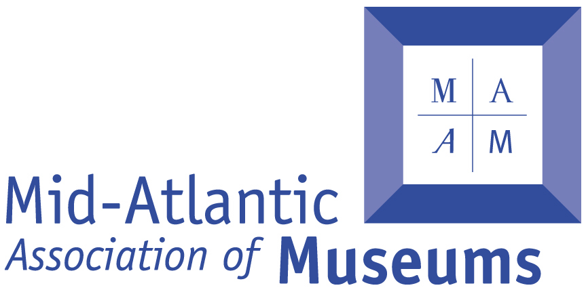
Mid-Atlantic Associations of Museums
2018 Building Museums® Symposium
CALL FOR SESSION PROPOSALS
Conference Dates: March 9-11, 2018 at the DoubleTree Philadelphia Center City, Philadelphia, PA
Submit Proposals to: MidAtlanticMuseums@gmail.com
Submission Deadline: Friday, September 15, 2017 by 5:00PM EST

Background:
For the past thirteen years, the Mid-Atlantic Association of Museums (MAAM) has hosted the Building Museums® Symposium – the only conference dedicated to educate and inform the museum community about the development of major capital projects. The symposium brings together museum staff and trustees, architects, engineers, planners, and project managers from across this country and abroad to learn, network, and mingle with some of the most experienced professionals who collaborate on museum building projects. We are now reaching out to the museum and allied building design and construction professionals to solicit the highest level of program presentation available.
The MAAM Building Museums® Symposium is unique in that it focuses on the planning, development and implementation of museum capital projects, including renovations, expansions and new buildings. Our three-day symposium will be comprised of various types of presentations: a full-day workshop, plenary and breakout sessions, behind-the-scenes tours, and social events. Attendees to our conference come from two sectors: (1) museum leaders and staff from a range of museum types and sizes, and (2) professionals in the planning, design, and construction fields. A significant number of museum attendees are from small to medium-sized institutions and we are actively seeking session proposals that discuss projects of interest to this audience.
From our experience in holding conferences, the best-received and most informative sessions actively engage the participants and share “real world” experiences in the development of museum building projects. This means sharing discussion of failures as well as successes, and offering insights into the decision-making process. Proposals that tailor presentations to provide guidance, lessons learned, and address issues associated with a project are especially sought by the Program Committee.
Session proposals should address one or more of the following topics:
- Leadership roles in museum building projects
- Strategic and master planning
- Budget and business planning
- The visitor experience
- Collections care and facility design
- Design and pre-construction processes
- Architect and contractor selection
- Fundraising
- Project communication – both internal and external
- Dealing with existing infrastructure and historic preservation
- Sustainable design
- Post-opening challenges
The Building Museums® Program Committee is looking for sessions that provide a clear and focused discussion of a specific project, bring a diverse range of participants to the table to exchange views, and can stimulate questions and conversations among the attendees. Presentations on smaller scale projects are encouraged, and for projects that are larger in scale, relating that experience to smaller projects would be of value to the symposium’s expected audience.
Session Selection Process:
The symposium Program Committee consists of representatives from the larger MAAM Building Museums® Committee and includes a broad spectrum of individuals with experience and training to be found on a typical museum project. The Program Committee will review session submittals during September and October 2017. After developing the schedule for the symposium, we will notify contact persons for selected sessions on or about November 1, 2017. The Program Committee reserves the right to request modifications to the submitted programs, and may combine multiple submissions into a single program.
Submission Deadline: Proposals will be accepted until 5:00PM on Friday, September 15, 2017. Please save electronic proposals in PDF format and use the program title and session chair, firm, or institution as the file name of the document. It is important to follow this naming convention, for example, Green Buildings_ABCAArch.Firm.pdf.
Submit proposals to MidAtlanticMuseums@gmail.com.
Evaluation Criteria:
- Strong, 200 word abstract clearly states the topic of the session and emphasizes the relevance to conference attendees.
- Session is clearly written and addresses session proposal guidelines.
- Goals and objectives of session proposal address needs and concerns of the field.
- Outcomes for problems and issues identified in the proposal are clearly stated and likely to be realized.
- The proposal addresses one or more of the symposium theme/topics.
- Audience for the session is clearly identified and the session subject is appropriate to the needs/concerns of this sector of the museum and/or planning professions.
- Session moderator and speakers are qualified to present the session and ensure the maximum audience engagement.
- All proposals must have at least one speaker from a museum.

Session Proposal Contents:
Proposals relating to any aspect of architecture, planning, landscape architecture, visitor experience including food service and retail, exhibits, technology, and the built environment will be considered. Session proposals may address local, urban, suburban, regional, or national issues.
Proposals will be evaluated on the strength of their 200-word abstract, the diversity of speakers and their experience, and relevance to the expected range of symposium attendees.
Successful session proposals will meet the continuing education needs of the museum community and the allied professional design and construction industry. Programs that are a sales pitch, either for products or services, or focus on a proprietary product or installation will not be accepted.
Session Formats:
Breakout sessions will typically be an hour and fifteen minutes in length; plenary sessions will be selected by the Building Museums® Program Committee based on their assessment of overarching value of a proposal to all of the symposium attendees. Consider one of the following popular formats when designing your session proposal:
- Case study: a common format, case studies present facts, problems, and/or data from a specific project with an opportunity for Q&A to simulate audience engagement
- Panel discussion: series of brief presentations about a topic or issue designed to engender lively exchange between speakers and the audience
- Round table discussion: a moderated but open unscripted discussion between experts and building team members. This format benefits from having dissimilar points of view that can spark questions and a dialogue among speakers, and among speakers and the audience.
Speakers:
Session proposals that include speakers who represent multiple disciplines (designers, planners, contractors, museum staff, etc.) are highly encouraged. We recommend that breakout session proposals include no more than four speakers including the moderator/facilitator and must include at least one museum staff member. Please confirm that all of the proposed speakers are available for the Building Museum Symposium dates before submitting a proposal. If a session is accepted, the contact person will be informed of the exact date and time of their session. It is the responsibility of the speakers to notify the Program Committee through MAAM of any change in title or place of employment so we can publish this updated information in the final printed symposium program or on the web.
Speaker Expenses and Required Symposium Registration:
MAAM cannot provide any financial reimbursement or assistance to speakers who wish to be compensated for travel or hotel expenses. All Building Museum speakers are expected to register at the conference discounted speaker rate that will be publicized in Fall 2017.

Increase Your Chances of Having Your Session Proposal Selected:
Successful session proposals are: (1) written in clear and concise language with an abstract that demonstrates how your program will engage and be of interest to our attendees, (2) propose a presentation that is new and not presented on a regular basis, (3) propose a session that discusses significant decisions and presents obstacles encountered and solutions realized, (4) have a presentation that includes a broad range of presenters (2 minimum, 3 preferred, and 4 maximum) who can discuss differing aspects and perspectives of your topic, and (5) carefully identifies speakers and their contact information as well as all of the information requested in the Request for Session Proposal section.
Request for Session Proposal Outline:
Please follow the outline below in proposing your session.
- Title: provide a short, benefits-oriented title that describes your session objective. Please note that the Building Museums® Program Committee and MAAM reserve the right to edit suggested titles for purposes of ensuring accuracy and maximum audience interest
- Contact Person: you must include the name, title, institution or firm and full contact information (address, email and telephone number) of the person submitting this session proposal. Typically, this is the same person who will chair or facilitate the session.
- Program Summary: a 50-word or less description that could be published in the Symposium printed program and/or website. The summary should accurately communicate the content of the session and the learning objectives. Please note that the Building Museum Program Committee and MAAM reserve the right to edit this description to market the session to the widest possible audience. Any such changes to the submitted program wording will be shared with the session contact person in advance.
- Program Abstract: this no more than 200-word session description should specify the content of the presentation, how it relates to the Symposium themes/topics, what the educational benefits of the session are, who the intended audience is, and what are the intended outcomes or take-ways from attending this session.
- Learning Objectives: list a minimum of four learning objectives. A “learning objective” is an explicit statement that clearly expresses what the audience member will be able to do after attending the session. For example, “attendees will understand the goals and minimum information for a building program.”
- Program Format: indicate the session type proposed for your session: e.g. case study, panel discussion, round table discussion, other format.
- Audience Experience Level: specify level addressed by your session – Entry, Intermediate, Advanced.
- Speakers: identify the moderator/facilitator and all proposed speakers including the following information for each: name, title, institution, address, email, phone number followed by brief bio (no more than 100-words) including education, training, experience and honors justifying their participation in your session and qualifications to speak as an expert on the topic. Include any professional or educational designations – e.g. AIA, ALA, PHD, PE, RLA, etc.
- Audio Visual Needs: MAAM will supply basic AV support: projector, microphone, and podium. Session speakers are responsible for providing a laptop computer to support digital presentation materials. Please alert us to any special AV needs.
- Attendees: please indicate if there is a limit to the number of attendees at your session.
DEADLINE FOR BUILDING MUSEUM SESSION PROPOSAL SUBMISSION:
5:00PM FRIDAY, SEPTEMBER 15, 2017

