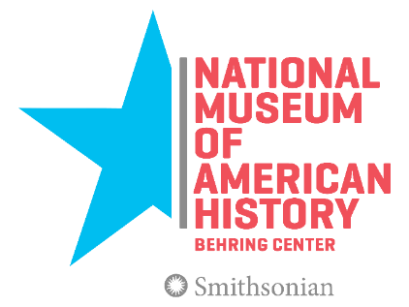
Smithsonian Career Opportunity

The Smithsonian Institution’s National Museum of American History
Project Manager, Smithsonian Jazz Masterworks Orchestra (SJMO) 2019 World Tour

In 2019, the Smithsonian’s resident jazz orchestra will engage audiences around the world through a dynamic 10-city world tour. We are seeking an experienced project manager to join our project team.

Position Involves
Developing and executing a wide variety of concert tour planning and logistics to include:
- Tracking and meeting project goals
- Working closely with and coordinating communication between Smithsonian Jazz program director (Tour Director), SJMO artistic director, key museum staff, musicians and guest artists, partners and external vendor support
- Developing and managing project meetings, timelines, travel schedules and milestones
- Identifying and managing external touring support for contracts
- Creating and managing budgets for the tour and related education and promotional activities
- Coordinating a marketing and communication strategy in collaboration with NMAH’s Office of Communication and Marketing and Office of Audience Engagement

The successful candidate must have strong project management skills and experience with large, complex cultural projects. Attention to detail, ability to set goals, strong communication skills and a proven record of accomplishment in problem solving is required. Prior experience in national or international tour management and work in performing arts management in large cultural institutions is a plus.
Salary Information
This is a two year term, trust funded (non-Federal) position at the IS-11 grade level. The annual salary is $68,036, including an excellent benefits package.

To apply, please send resume and cover letter to NMAHApplications@si.edu with the subject “SJMO Project Manager”. Applications will be accepted until midnight, Monday, March 5, 2018.

Questions? Contact Ken Kimery at kimeryk@si.edu or (202) 633-3587

