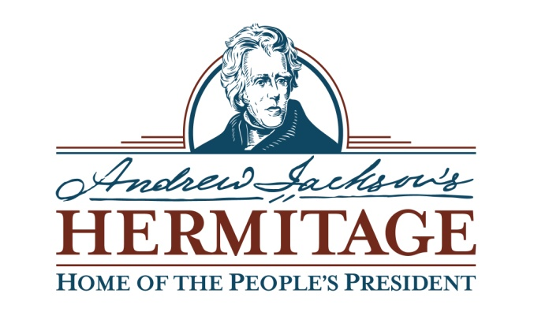
Chief of Museum Operations Advertisement

The Andrew Jackson Foundation seeks an experienced museum professional to serve in the newly created position of Chief of Museum Operations (CMO). This position manages the day-to-day museum operations of Andrew Jackson’s Hermitage in Nashville, TN. The Hermitage is a 129-year-old presidential home museum and one of the nation’s first National Historic Landmark sites. It includes the 1,120 acre property, 27 buildings, and a full and part-time staff of 106. The CMO will report directly to the President and CEO, and be a member of the museum’s executive management team. Working with their direct reports, the CMO will provide leadership and direction in the planning, controlling, and general operation of the museum (e.g., collections management, research, educational and interpretive programming, public programming, guest services, preservation of buildings and sites, property management, and security). The ideal candidate will have extensive knowledge of museum management principles and administrative practices; strong skills in project management and execution; and experience in budget development and management. The CMO position requires an advanced degree and a minimum of 10 years of relevant experience in museum and non-profit management, and a combination of knowledge and experience in American history, collections management, historic preservation, interpretation, and public history.

Applications are due no later than close of business on Friday, March 30, 2018. A complete application must include: 1) cover letter expressing the applicant’s interest in the position and the institution and why they believe they are a good fit for this position, 2) a current, up-to-date resume and/or curriculum vita, 3) four writing samples relevant to the position requirements, and 4) five professional references. A lack of any of these components will disqualify the applicant from further consideration. Applications are strictly confidential, and must be sent electronically. Paper applications will not be accepted. For a complete position description interested parties should contact: CMOsearch@thehermitage.com.

The Andrew Jackson Foundation is a 501(c)(3) corporation. It strictly adheres to an equal opportunity policy.

