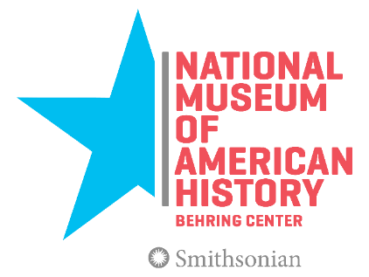
Digital Marketing and List Manager

Smithsonian Institution
National Museum of American History
Office of Audience Engagement

Do you want to lead a national conversation around shared American ideals and ideas that join us as a people? Do you want to see more people—online and onsite—engage with the National Museum of American History? Join the Office of Audience Engagement and help lead the museum’s digital marketing, communications, and promotional efforts!

The National Museum of American History (NMAH) is seeking a Digital Marketing and List Manager to develop and implement an exciting new digital movement focusing on the work of the Office of Audience Engagement (OAE) to support the full activities of NMAH. This position serves as a manager in the department of Programs and Audience Development. In this position, the manager seeks to make deeper connections to the museum’s current and future audiences, with a focus on audiences in the greater Washington, D.C., metro area, families, young adults, and working professionals.

The Digital Marketing and List Manager will:

- Lead the museum’s marketing and digital strategy as it relates to all programs, activities, and initiatives of OAE, working in collaboration with the Director of Programs and Audience Development and other members of the Programs and Audience Development Department.
- Develop and implement the museum’s email newsletters and related digital marketing strategies, managing the museum’s email lists and developing strategies for email marketing growth.
- Lead and evaluate all digital marketing and promotional campaigns, including paid advertising and organic social media content.
- Advocate for, spread, and implement new and fresh ideas for promotion and engagement.
- Leverage and apply a leading understanding of the latest trends and approaches to social media, eNews, and other digital marketing trends; including evaluation of these programs.
- Establish and coordinate collaborative partnerships with a variety of national, state, and local organizations and business in support of all marketing, communications, and community-building efforts as it relates to OAE and NMAH.
- Set and manage project schedules, organize and convene meetings, and communicate with partners, internal stakeholders, and staff.
- Coordinate with internal and existing civic engagement projects and other museum themes.
- Manage and coordinate internal resources and personnel to successfully execute all projects and programs.

Five or more years’ experience in marketing, communications, and promotion, with emphasis on social media, eNews, video, or storytelling, is required. The successful candidate will have excellent writing and communication skills, creative problem solving skills, organization and time management skills, leadership and management abilities, a positive attitude and sense of humor, and demonstrated knowledge and interest in American history and civic engagement. Experience managing projects with multiple stakeholders and competing priorities, budgeting, and working in a fast paced environment is a must.

Salary: IS-11 – $68,036 to $88,450 per year with promotion potential, plus an excellent benefits package

To apply, please submit a resume and cover letter by email with the subject “Digital Marketing and List Manager” to NMAHApplications@si.edu. Applications will be accepted until Monday, July 30, 2018, at midnight.

The Smithsonian is an Affirmative Action/Equal Opportunity Employer. Women, minorities, people with disabilities, and candidates of all backgrounds are encouraged to apply.

