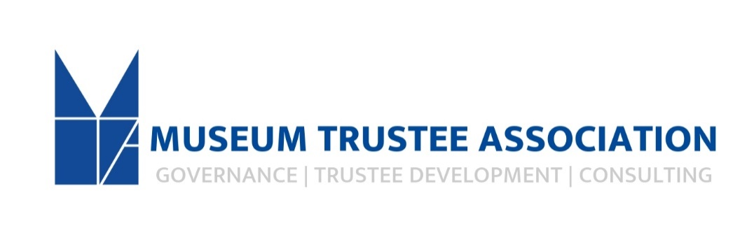

The Museum Trustee Association
Position: MTA Team Administrator
We are seeking diverse, qualified candidates to apply for the Administrator role at the Museum Trustee Association (MTA). As the organization continues forward momentum, we would like to secure a team member that is engaged in our mission. The position requires at least one to two years of office experience.
The Administrator serves as the main support staff for all aspects of AAMC and AAMC Foundation, and reports to the Executive Director, and works closely with the Membership, Marketing and Communications Coordinator. Primary areas of focus are programming administration, scheduling, operations and clerical. The position is the main point of contact for our members. The role will require familiarity with managing mailing lists and mail merging correspondence, as well as experience with different information technologies and with utilizing online platforms such as Constant Contact, Salesforce, Zoom and more.

The position requires a proactive individual, that is efficacious when working independently. To be successful in the role one must be a capable multitasker, work fluidly between areas of focus, produce a high quality of work, possess a strong overall work ethic and have a fully developed and advanced time management skill set. In addition, one will need to possess strong problem-solving abilities, excellency in oral and written communications, and an aptitude to meet changing deadlines. It is essential that the administrator be a highly organized and detail-oriented individual that can work in a quiet environment with little supervision. Understanding of nonprofit art organization structure is key. A minimum of one to two years full-time employment within the arts, nonprofit or similar field is required
Responsibilities:
Team driver and collaborator for organizational timeline and ensures that timelines are reasonable, met and that relevant materials are distributed accordingly.
Coordinates with external clients, board consultants and staff.
Sets and manages CEO’s meeting and travel schedule as well as manage all calendars for program participants/speakers and internal team as they pertain to programs, including webinars, gatherings, awards and more.
Creates and distributes board packets and other updates including agendas, reports, meeting minutes and relevant information and ensures their distribution in a timely manner.
Creates proposals and visuals for team appearances at conferences and lectures.
Manages all aspects of MTA conferences, workshops and patron weekends including audio-visual, catering, registrations, transportation, sponsorship proposals and acknowledgements, and other dealings with outside suppliers.
Oversee, maintain, share and update RSVP and attendee lists for programs to move forward follow-up, donation solicitations, and membership inquiries, and more.
Executes activities regarding individual and institutional membership including responding to inquiries, stewarding relationships, maintaining membership files/records, sending solicitations, acknowledgements, and general correspondence.
Ensure recognition of institutional and individual membership is correct and updated in print and online. Deliver membership statistics and reports as requested.
Ensure that the website and all online platforms are accurate and up to date, specifically in regards to membership, events and member resource center.
A member of the overall team that supports MTA template sales, on-line set-up and customer service.
Generates mailing lists, solicitations, conferences, and prepares marketing materials for distribution.
Maintains MTA CRM’s accounts in a timely manner regarding additions, changes and new initiatives.
Attends Association events and industry conferences as needed. Requires some night and weekend travel (15%).
Maintain office files and supplies.
Other projects as assigned.

Competencies:
Familiarity and interest in the museum community
Proactive and efficacious when working independently
Attention to detail and organizational capacity
Ability to manage multiple projects simultaneously, prioritize within tight deadlines, while producing a high quality of work
Digital Marketing, including photo editing and e-communications
Exceptionally strong interpersonal and communication skills, written and spoken
Ability to maintain confidentiality
A strong overall work ethic
A fully developed and advanced time management skill set
Strong problem-solving abilities
Financial aptitude
Ability to work in a quiet setting

Preferred Qualifications:
Bachelor’s degree in liberal arts or business discipline
2 years’ experience in nonprofit administration
Demonstrated ability with software packages including Microsoft Office Suite (excel and power point), Constant Contact, Website Creator, Zoom, Survey Monkey, Adobe Creative Suite and others.
Position is 40 hours a week, Monday – Friday, 9:00am – 5:00pm with occasional weekend and evening work. Requires some travel (15%) within the US and Canada. Generous vacation, sick and holidays as well as shared cost of health benefits and retirement plan with organizational matching ( after 1 year of employment).
Salary is based on experience, $34,000-38,000
Offices are located in downtown Baltimore within the Maryland History Center with free parking available.

The Museum Trustee Association is an equal opportunity employer. All applicants will be treated without regard to race, color, religion, sex, national origin, age, disability, sexual orientation, military or veteran status, gender identity, or any other factor protected by law. Please note this job description is not designed to cover or contain a comprehensive listing of activities, duties or responsibilities that are required of the employee for this role. Duties, responsibilities, and activities may change at any time with or without notice. This job operates in a professional office environment. This role routinely uses standard office equipment such as computers, phones, photocopiers, filing cabinets, and scanners and fax machines. The position reports to an ADA compliant office and is principally sedentary, which includes sitting for periods of time in front of a computer at a desk. Needs to be able to lift 50 pounds.

This is a full-time position. To apply please email a resume, cover letter with three professional references to anne@museumtrustee.org. Incomplete applications may not be considered. No phone calls please.

