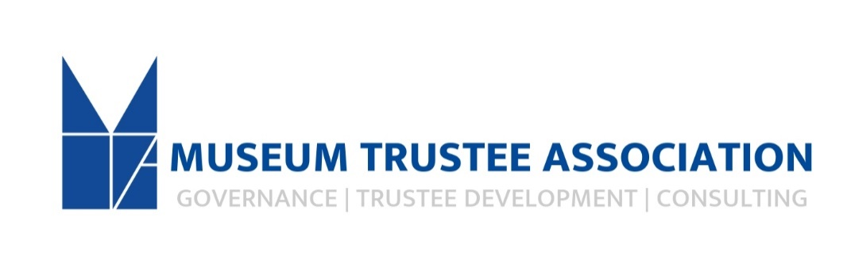

The Museum Trustee Association
Position: Association Team Administrator
The Museum Trustee Association is a national organization that supports, educates and inspires Trustees in order to enhance their effectiveness for the benefit of the institutions they serve. The association adopted a new strategic plan and is in a time of growth. We are seeking diverse, qualified candidates to apply for the Administrator role at the Museum Trustee Association (MTA). As the organization continues forward momentum, we would like a new team member that is engaged in our mission. The position requires at least one to two years of office experience.
Responsibilities:
Team driver and collaborator for organizational timeline and ensures that timelines are reasonable, met and that relevant materials are distributed accordingly.
Coordinates with external clients, board, consultants and staff.
Sets and manages CEO’s calendar for meetings, events and travel schedule as well as manage all calendars for program participants/speakers and internal team as they pertain to programs, including webinars, gatherings, awards and more. Follows-up all scheduling with monthly expense and reimbursement reports.
Coordinates Board communications including creating and distributing board packets and other updates including agendas, reports, meeting minutes and relevant information and ensures their distribution in a timely manner.
Creates proposals and visuals for team appearances at conferences and lectures.
Manages all aspects of MTA conferences, workshops and patron weekends including audio-visual, catering, registrations, transportation, sponsorship proposals and acknowledgements, and other dealings with outside suppliers.
Oversee, maintains, share and update RSVP and attendee lists for programs to move forward follow-up, donation solicitations, and membership inquiries, and more.
Executes activities regarding individual and institutional membership including responding to inquiries, stewarding relationships, maintaining membership files/records, sending solicitations, acknowledgements, and general correspondence.
Ensure recognition of institutional and individual membership is correct and updated in print and online. Deliver membership statistics and reports as requested.
Ensure that the website and all online platforms are accurate and up to date, specifically membership, events and member resource center.
A member of the overall team that supports MTA template sales, on-line set-up and customer service.
Generates mailing lists, solicitations, conferences, and prepares marketing materials for distribution.
Maintains MTA CRM’s accounts in a timely manner regarding additions, changes and new initiatives.
Attends Association events and industry conferences as needed. Requires some night and weekend travel (15%).
Maintains general office supplies, maintains office area, manages mail, correspondence, and Interfaces with controller for accurate financial reporting.
Other projects as assigned.

Competencies:
Familiarity and interest in the museum community
Proactive and efficacious when working independently
Attention to detail and organizational capacity
Ability to manage multiple projects simultaneously, prioritize within tight deadlines, while producing a high quality of work
Digital Marketing, including photo editing and e-communications
Exceptionally strong interpersonal and communication skills, written and spoken
Ability to maintain confidentiality
A strong overall work ethic
A fully developed and advanced time management skill set
Strong problem-solving abilities
Financial aptitude
Ability to work in a quiet setting

Preferred Qualifications:
Bachelor’s degree in liberal arts or business discipline. MA in museum studies or art history preferred.
2 years’ experience in nonprofit administration
Demonstrated ability with software packages including Microsoft Office Suite (excel and power point), Constant Contact, Website Creator, Zoom, Jot Form, Adobe Creative Suite and others.
Position is 40 hours a week, Monday – Friday, 9:00am – 5:00pm with occasional weekend and evening work. Requires some travel (15%) within the US and Canada. Generous vacation, sick and holidays as well as contribution towards cost of health benefits and retirement plan with organizational matching (after 1 year of employment).
Salary is based on experience, $35,000-40,000
Offices are located in downtown Baltimore within the Maryland History Center with free parking available.
The Museum Trustee Association is an equal opportunity employer. All applicants will be treated without regard to race, color, religion, sex, national origin, age, disability, sexual orientation, military or veteran status, gender identity, or any other factor protected by law. Please note this job description is not designed to cover or contain a comprehensive listing of activities, duties or responsibilities that are required of the employee for this role. Duties, responsibilities, and activities may change at any time with or without notice. This job operates in a professional office environment. This role routinely uses standard office equipment such as computers, phones, photocopiers, filing cabinets, and scanners and fax machines. The position reports to an ADA compliant office and is principally sedentary, which includes sitting for periods of time in front of a computer at a desk. Needs to be able to lift 50 pounds.

This is a full-time position. To apply please email a resume, cover letter with three professional references to anne@museumtrustee.org. Incomplete applications may not be considered. No phone calls please.

