For release on 1/29/2024
From: The Mid-Atlantic Association of Museums, 2024 Building Museums
Contact: Kahla Woodling DeSmit, Executive Director, Mid-Atlantic Association of Museums, director@midatlanticmuseums.org, 607-431-8248

BUILDY AWARD PRESS RELEASE
THE MIT MUSEUM AND THE PEALE TO BE HONORED AS
2024 BUILDY AWARD WINNERS

The Mid-Atlantic Association of Museums (MAAM) is excited to announce two recipients for this year’s Building Museums™ Symposium’s Buildy Award: The MIT Museum in Cambridge, Massachusetts and the Peale Center for Baltimore History and Architecture in Baltimore, Maryland. The Buildy Award recognizes both museums for their leadership and exemplary accomplishment through the planning, construction, and life after opening. MIT Museum Director of Galleries & Exhibitions Ann Neumann and The Peale’s Chief Strategy Officer and founding Director, Nancy Proctor, will accept their museums’ awards on March 8, 2024, during MAAM’s 19th Building Museums™ Symposium. The award recognizes the museums as an institution, their director and staff, and the design and construction teams whose completed museum projects demonstrate high achievement in the lessons of the Building Museums™ Symposium: careful, creative planning and diligent implementation, leading to institutional sustainability. The purpose of the Buildy Award is to increase awareness within the field, and by the public at large, of the value of museums and the need for their ongoing creation, rehabilitation, and expansion to serve future generations.
This year, the Buildy Award Selection Committee of the Building Museums™ Symposium chose to honor these two museums, in part, because each addressed different and significant challenges: the MIT Museum: a new museum and exhibit fit-out in the lower three floors of a new 17 story office and research building at the Kendall Square campus gateway; and the Peale: the revitalization of the country’s oldest purpose built museum to serve its community through grassroots-up programming and hands-on training in architectural preservation skills.
The MIT Museum embodies the university’s motto of “Mind and Hand” through enticing exhibitions incorporating more than twenty interactives, a maker space within the museum and an exhibit on MIT culture. The museum seeks to provide visitors of all abilities and backgrounds with access to science, engineering, math and experimental art that reflects the university’s significant contributions and demonstrates the potential for science to benefit humanity and the planet. Its design packs much into its 56,000 square foot space. The $111 million museum achieved a LEED Gold certification within the larger building that is also certified as LEED Gold.
The Buildy Award Committee noted several factors that contributed to the success of The MIT Museum:
- The high quality of design, particularly for the exhibits, but also in the overall museum fit-out and the larger gateway building that forms its setting. The award committee noted the many interactives that were extensively prototyped digitally and physically to ensure universal design and accessibility. The engaging design of the public spaces is both welcoming and exciting and expresses a sense of future possibilities.
- The sustainable design of the project to eliminate VOCs, incorporate LED lighting and provide accessible, inclusive and sustainable approaches throughout. Some of these included selections of materials (cork, felt, sustainable carpeting, woods or metals), assembly methods and graphics production that considered post-life disassembly or easy recycling. The exhibit text was directly printed or silk-screened to avoid adhesives and vinyl.
- The skill and perseverance of its now retired director, the museum leadership team and the staff to achieve the new museum over a period of many years in a project with a complex delivery structure involving multiple architects, the university and a private developer.

The MIT Museum was a collaborative effort of several design firms. The exhibits are the work of Studio Joseph leading the team that included Bluecadet (media) Pentagram (interpretive design) and Tillotson Associates (lighting). The architect for the Museum Fit-out was Howeler and Yoon. The larger building is the work of Design Architect Weiss Manfredi and Project Architect Perkins & Will. A master plan for the museum developed by Atelier Bruckner provided a framework for the designers. Exhibits were constructed by Kubik Maltbie, with base building by Turner Construction.

The Peale Center for Baltimore History and Architecture (The Peale) brings new life to the first purpose-built museum in the Americas, both architecturally and organizationally. The Peale’s National Historic Landmark building was designed by architect Robert Carey Long, Sr. for artist Rembrandt Peale who operated the museum from 1814-1829. It then became Baltimore’s City Hall (1830-1875), one of its first public schools for African Americans (1878-1887), a mix of commercial and industrial uses (1888-1929) and more recently, Baltimore’s first municipal museum (1930-1997). When the city museum closed, its collection was transferred to the Maryland Historical Society and the building was abandoned for twenty years prior to the 2017 initiation of renovations for its current reincarnation. As Baltimore’s community museum, The Peale’s purpose is to record and present Baltimore stories through exhibitions, performances and events created by local artists and storytellers from Baltimore’s diverse communities. Additionally, it conducts a training and apprentice program for exhibition preparation and the historic preservation trades. It is managed by a shared leadership team and its programming is driven by Baltimore’s creative communities.

The Buildy Award Committee noted several factors that contributed to The Peale’s success:
- The involvement of the community in the development of the design and its programming and the impact The Peale is making with the community through programs, including the apprenticeship program for exhibition preparation and historic preservation trades that is unique for a museum.
- The remarkable and sustainable revitalization of a significant historic landmark. The Committee noted the installation of an all-electric HVAC system and the gentle refurbishment of existing building fabric and finishes that is inherently sustainable and provides for a healthy interior environment.
- The beautiful rejuvenation of The Peale’s garden space and its extension into the adjacent alley. A new elevator fronting the alley provides accessibility to the building.

The Architects for the Peale’s recent $5.3 million renovation were Walter Schamu, Principal in Charge, and Ron Masotta, Project Architect, of SM+P Architects. Construction was by A.R. Marani, Ruff Roofers, and C&H Restoration and Renovation, Inc.
The Buildy Award is the only award program that recognizes the museum leadership and design team for their part in guiding the planning and construction process to a high level of success. Projects of different scales, types and budgets are eligible, with the emphasis being on the impact of the project. The museum director must address the competing interests of staff, trustees, financial contributors, artists, architects, engineers, contractors, visitors, and other parties. Winners of the Buildy Awards have managed to guide their teams to create lasting assets for their institutions and their communities within a financially sustainable framework.
The Buildy Award Selection Committee consisted of the following participants:
- Ann Trowbridge, Smithsonian Institution, Washington, D.C., Chair
- Kahla DeSmit, Executive Director, MAAM
- Jackie Eyl, KID Museum, Bethesda, MD
- Amanda Gillen, Frick Museum, Pittsburgh, PA
- David Searles, Jacobs/Wyper Architects, Philadelphia, PA
- Sandra Vicchio, Sandra Vicchio Associates, Baltimore, MD
- Nancy Walsh, Denver Museum of Nature & Science, Denver, CO
- Nick West, Colgate University Museums, Hamilton, NY

MIT MUSEUM

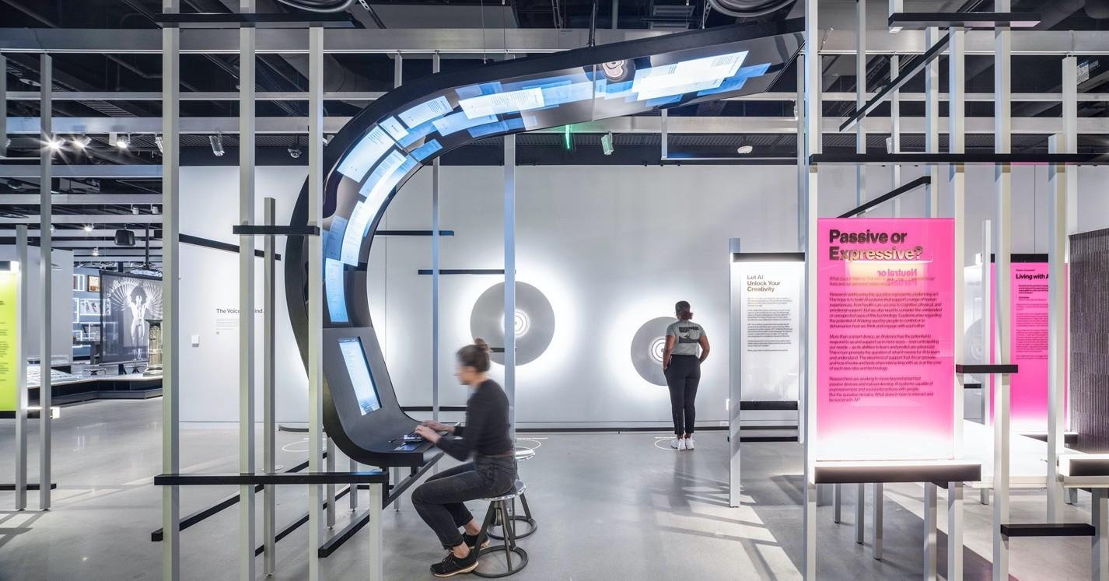
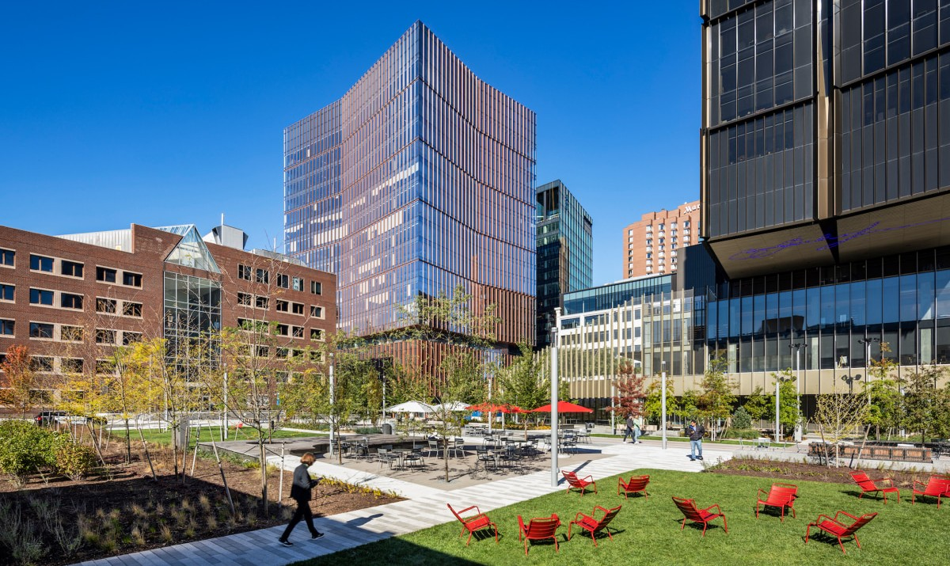
Collaborative Poetry exhibit, in the AI:Mind the Gap exhibition. Visitors co-create poetry with AI, publishing the creative efforts on the overhead screen in the gallery. Photography by Alex Fradkin.

The newly created open space in the campus gateway, and MIT Museum located on the first three podium floors of the tower.

MIT MUSEUM

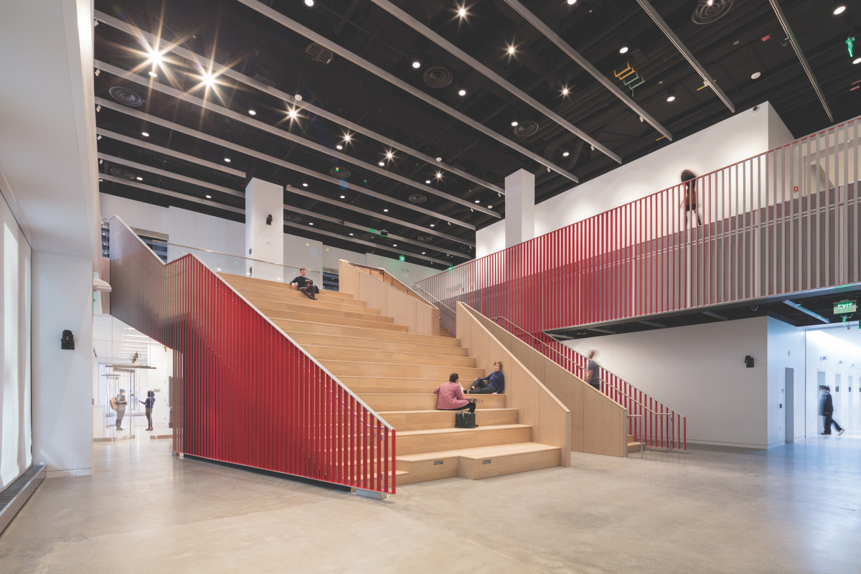
The Exchange is a community meeting and convening space located at the heart of the Museum. It hosts an active program of presentations, symposia, talks and social events.
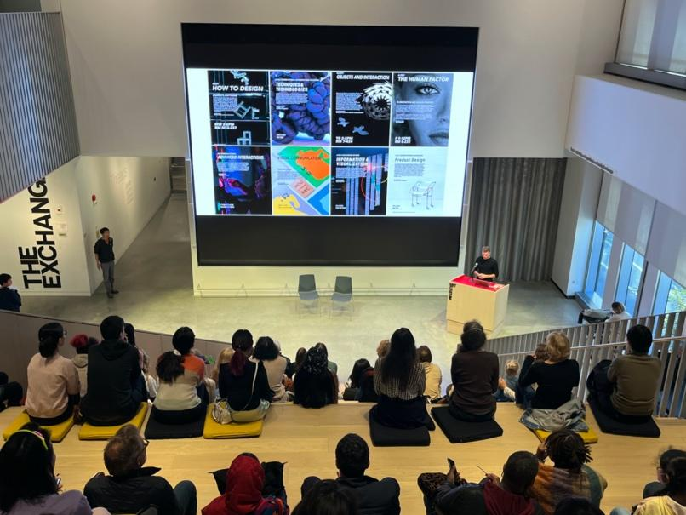

MIT MUSEUM

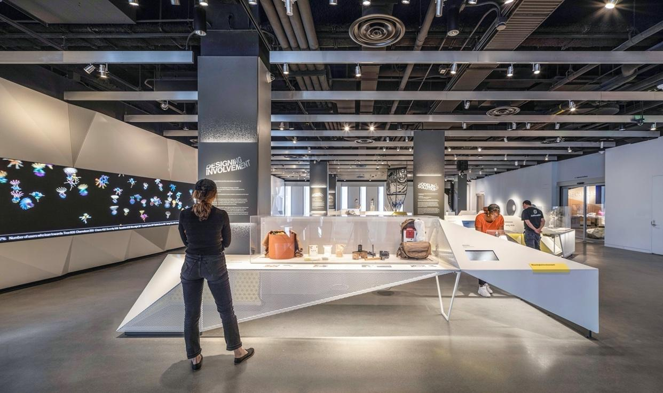
Essential MIT showcases the process, people and ideas that are distinctive to the ethos of MIT with projects that have shifted our perceptions and sparked leaps of understanding. Photography by Alex Fradkin.

The Peale

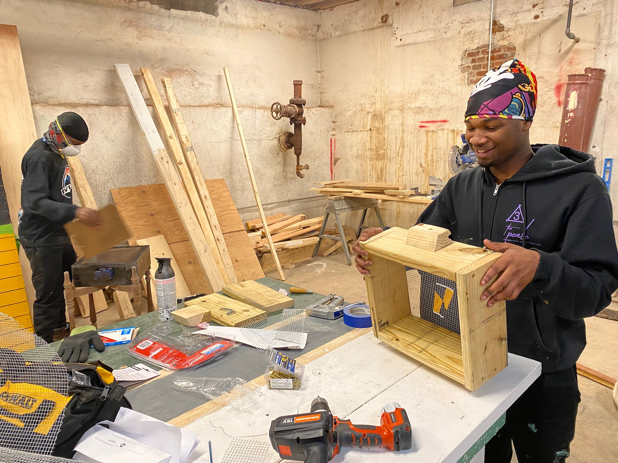
With a small, electric, energy-efficient HVAC now in the attic, the basement can be used for training apprentices in historic preservation trades and exhibition preparation. Pictured here are 2021-2022 apprentices, Jay’Quan Washington and Tavon Phillips, who now work as exhibition preparators at The Peale.

The Peale

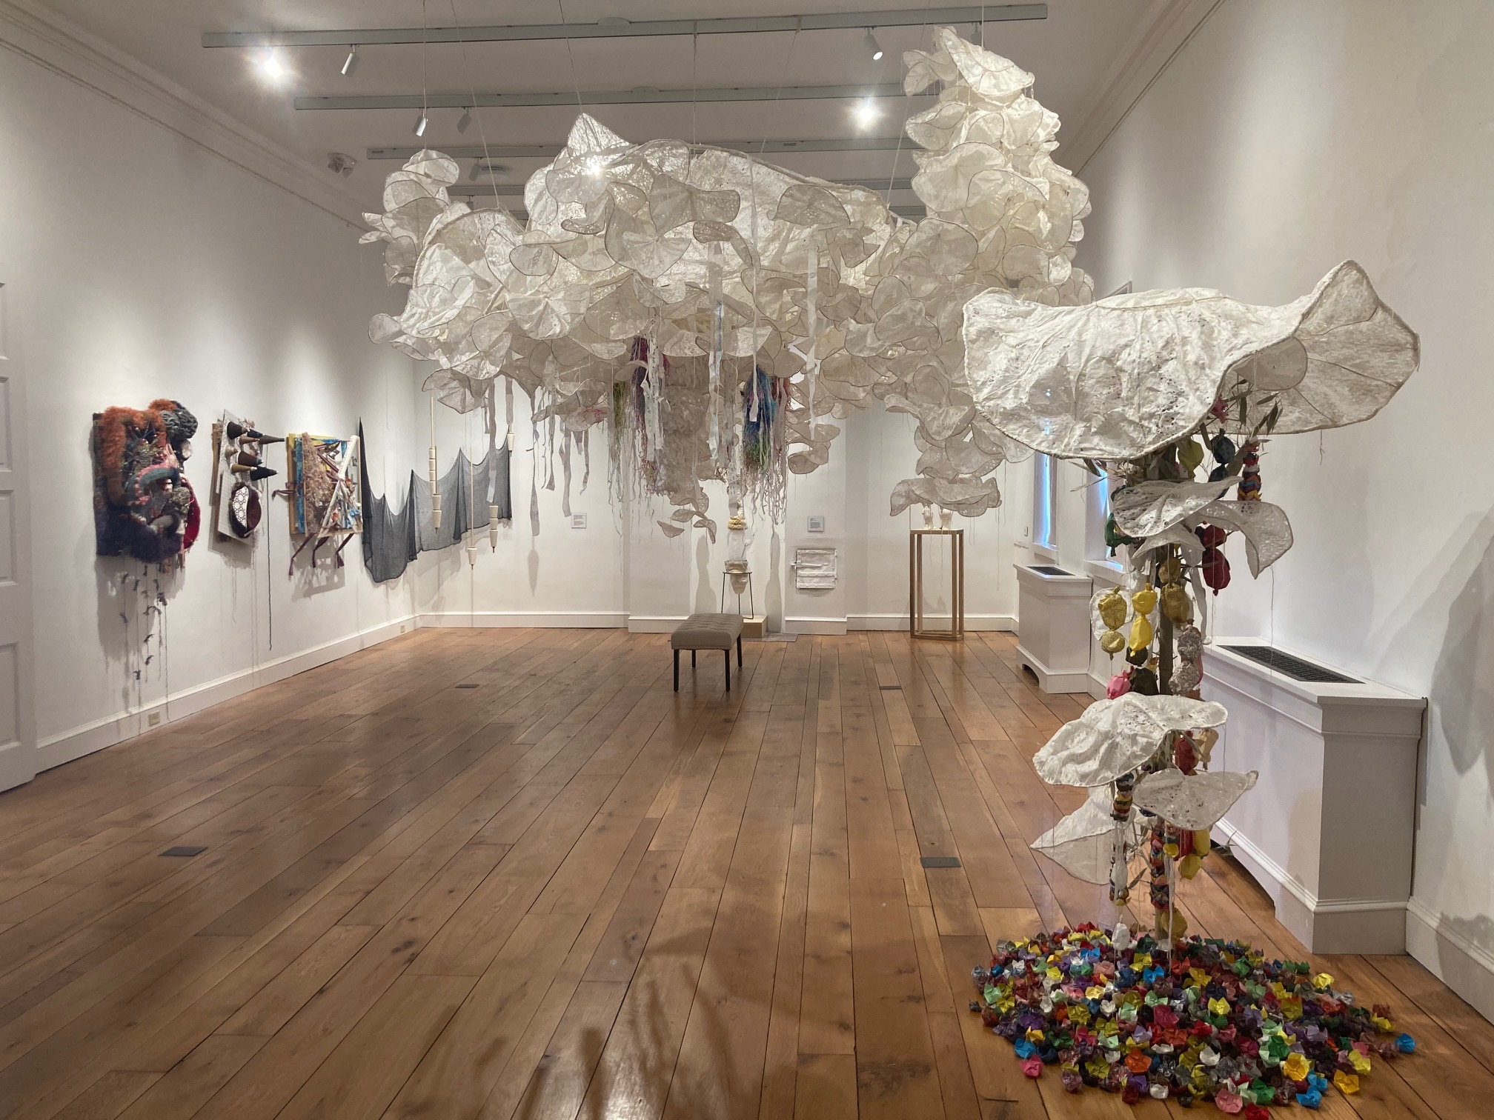
The Peale’s historic galleries now showcase a wide range of community-created programming, including contemporary art exhibitions like the 2022 Spark: New Light exhibition featuring works by faculty and students at UMBC and Towson Universities.

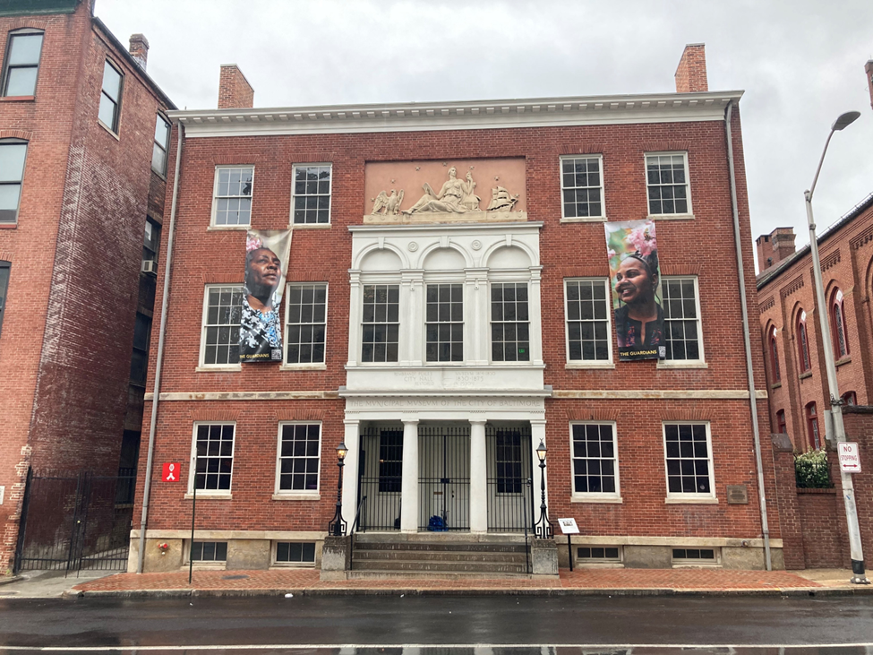
The exterior masonry, windows, doors, and portico of the Peale Museum building were restored by C&H Restoration and Renovation. It now serves as a backdrop for the portraits and stories of Black women leaders from Baltimore’s neighborhoods featured in The Guardians of Baltimore project.

THE PEALE

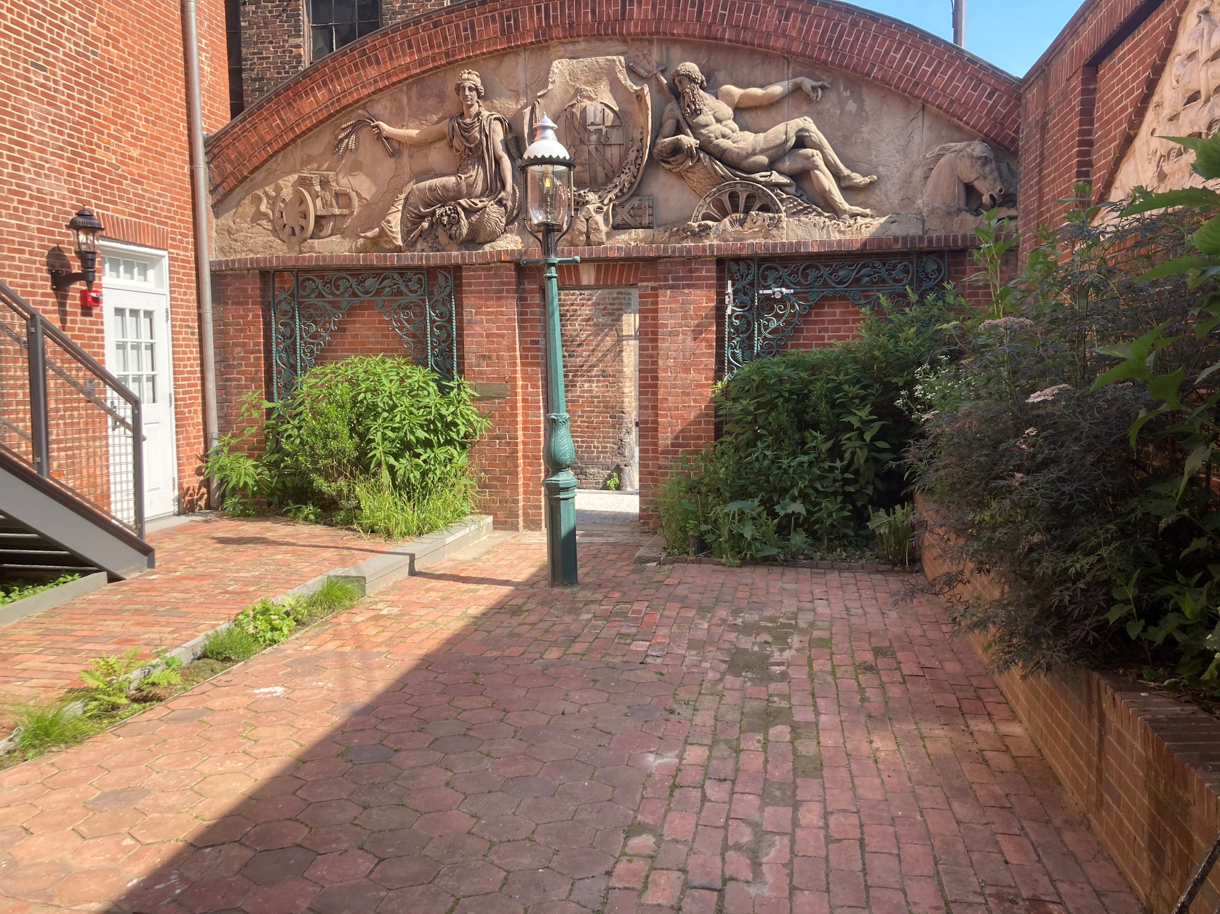
The Peale’s garden includes this 1806 relief by Italian artists Andrei and Franzoni, now the oldest still extant work of architectural sculpture in the U.S.

